Geometry: Unit 3, Lesson 6

- What are the types of angle pairs that are congruent when two parallel lines are intersected by a traversal?

Alternate Interior Angles and Corresponding Angles

- What angle pairs are supplementary when two parallel lines are intersected by a traversal?

Linear Pair and Consecutive Interior Angles

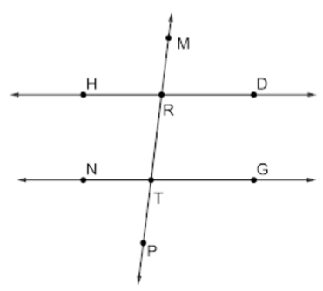
- Lines $HD$, $NG$, and $MP$ are shown, where $\overset{⃡}{HD}∥\overset{⃡}{NG}$ and $\overset{⃡}{MP}$ is a traversal. $m∠HRM=(9m-12)°$ and $m∠PTN=\left(4m+10\right)°$. What is the equation to solve for $m$?

$$\left(9m-12\right)+\left(4m+10\right)=180$$

